**Second Assignment (Math Game)**

Name: Gihoon Kim

Student #: 133229187

Section: C

Professor: Kadeem Best

**First Page**

**HTML**

<!DOCTYPE html>

<html>

<head>

<meta charset="utf-8" />

<title></title>

<link href="../../CSS/FirstPage/StyleSheet.css" rel="stylesheet" type="text/css" />

</head>

<body id="body1">

<h1> <span style="color:yellow">Magic</span> <span style="color:red">Math Game</span> </h1>

<div id="music"></div>

<section id="chooseLevel">

<div id="level1">

<div id="level1Container" class="levelContainer"></div>

</div>

<div id="level2">

<div id="level2Container" class="levelContainer"></div>

</div>

<div id="level3">

<div id="level3Container" class="levelContainer"></div>

</div>

</section>

<section id="startRule">

<div>

<a id="start">START</a>

</div>

<div>

<a id="rule" href="../Rules/HtmlPage.html">RULES</a>

</div>

</section>

<div id="restoreContainer">

<input type="button" id="restoreBtn" value="Restore" />

</div>

<script src="../../JavaScript/FirstPage/JavaScript.js"></script>

</body>

</html>

**CSS**

* {

padding:0;

margin:0;

text-align:center;

}

h1 {

font-size:5rem;

}

#chooseLevel {

display: grid;

grid-template-columns: 1fr 1.5fr 1fr;

}

.levelContainer {

margin-bottom: 2rem;

background-position: center;

background-repeat: no-repeat;

background-size: cover;

}

#level1Container {

background-image: url("../../Image/onePair.jpg");

height: 100px;

}

#level2Container {

background-image: url("../../../Image/flush.jpg");

height: 130px;

}

#level3Container {

background-image: url("../../../Image/royalStraightFlush.jpg");

height: 100px;

}

#startRule {

display:grid;

grid-template-columns: 1fr 1fr;

padding: 15rem 0;

}

a {

text-decoration:none;

font-size:3rem;

color:red;

}

body {

background-image: url("../../Image/magic.jfif");

height:100vh;

background-position: center center;

background-repeat: no-repeat;

background-size: cover;

}

#music {

position:absolute;

background-image:url("../../Image/play.jpg");

width:50px;

height:50px;

background-size:cover;

background-repeat:no-repeat;

background-position:center;

}

#restoreContainer {

position: absolute;

z-index: 30;

}

#restoreBtn {

width: 80px;

height: 2rem;

}

**JavaScript**

const container1 = document.querySelector("#level1");

const container2 = document.querySelector("#level2");

const container3 = document.querySelector("#level3");

const addAdd = document.createElement("p");

addAdd.style.color = "white";

addAdd.style.fontSize = "1.1rem";

addAdd.innerHTML = "ADD (Example 8 + 1 = 9)";

const addSub = document.createElement("p");

addSub.style.color = "red";

addSub.style.fontSize = "1.1rem";

addSub.innerHTML = "SUB (Example 8 - 3 = 5)";

const addDiv = document.createElement("p");

addDiv.style.color = "white";

addDiv.style.fontSize = "1.1rem";

addDiv.innerHTML = "DIV (Example 8 / 2 = 4)";

const music = document.querySelector("#music");

const body1 = document.querySelector("#body1");

music.style.left = `${body1.offsetWidth - 100}px`;

music.style.top = `${30}px`;

var audio = new Audio("../../Audio/Shallow .mp3");

audio.play();

let flag = 1;

music.addEventListener("click", () => {

// play music when it is paused

if (flag) {

music.style.backgroundImage = "url(../../Image/Pause.png)";

audio.play();

flag = 0;

}

// pause music

else {

audio.pause();

music.style.backgroundImage = "url(../../Image/play.jpg)";

flag = 1;

}

});

const start = document.querySelector("#start");

start.addEventListener("click", () => {

var musicTime = audio.currentTime;

localStorage.setItem("Music", musicTime);

window.location.href = "../SecondPage/HtmlPage.html";

})

container1.appendChild(addAdd);

container2.appendChild(addSub);

container3.appendChild(addDiv);

const restoreContainer = document.querySelector("#restoreContainer");

const restoreBtn = document.querySelector("#restoreBtn");

restoreContainer.style.top = `${body1.offsetHeight - 100}px`;

restoreBtn.addEventListener("click", () => {

if (JSON.parse(localStorage.getItem("level") == 1))

window.location.href = "../Level1/HtmlPage.html";

else if (JSON.parse(localStorage.getItem("level") == 2))

window.location.href = "../Level2/HtmlPage.html";

else if (JSON.parse(localStorage.getItem("level") == 3))

window.location.href = "../Level3/HtmlPage.html";

})

**Screen**

Screen of First Page

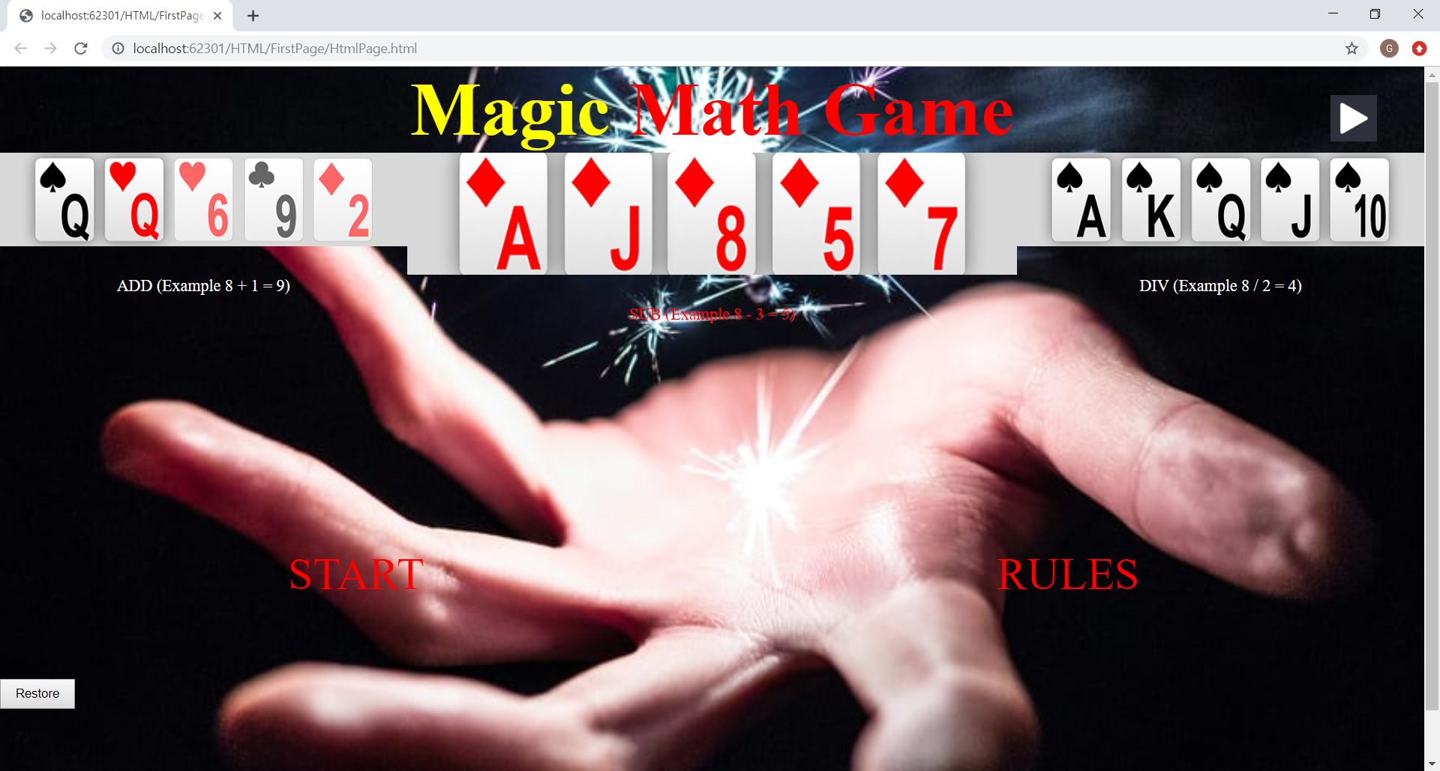

**Second Page (Input Data)**

**HTML**

<!DOCTYPE html>

<html>

<head>

<meta charset="utf-8" />

<title></title>

<link href="../../CSS/SecondPage/StyleSheet.css" rel="stylesheet" type="text/css" />

</head>

<body id="body">

<div id="music"></div>

<div id="container">

<form method="post">

<label> Name </label>

<input type="text" id="nameText" /> <br /><br />

<label> Age </label>

<input type="text" id="ageText" /> <br /><br />

<input type="button" value="Play" id="playBtn" />

</form>

</div>

<script src="../../JavaScript/SecondPage/JavaScript.js"></script>

</body>

</html>

**CSS**

* {

padding:0;

margin:0;

}

#container {

padding: 40vh 40vw;

}

label {

color:blue;

font-weight: bold;

}

#music {

background-image:url("../../Image/Pause.png");

position: absolute;

width: 50px;

height: 50px;

background-size: cover;

background-repeat: no-repeat;

background-position: center;

}

form {

padding: 2rem;

display:inline-block;

text-align:center;

}

#playBtn {

position:center;

background:none;

border:none;

color:red;

font-size:2rem;

font-weight:bold;

}

body {

background-image: url("../../Image/magic.jfif");

background-size: cover;

background-repeat: no-repeat;

background-position:center;

}

**JavaScript**

const playBtn = document.querySelector("#playBtn");

let name = document.querySelector("#nameText");

let age = document.querySelector("#ageText");

const music = document.querySelector("#music");

const body = document.querySelector("#body");

music.style.left = `${body.offsetWidth - 100}px`;

music.style.top = `${30}px`;

var audio = new Audio("../../Audio/Shallow .mp3");

audio.currentTime = JSON.parse(localStorage.getItem("Music"));

audio.play();

let flag = 1;

music.addEventListener("click", () => {

// play music when it is paused

if (flag) {

music.style.backgroundImage = "url(../../Image/Pause.png)";

audio.play();

flag = 0;

}

// pause music

else {

audio.pause();

music.style.backgroundImage = "url(../../Image/play.jpg)";

flag = 1;

}

});

const playGame = () => {

const userData = {

userName: name.value,

userAge: age.value

}

if (name.value != `` && !isNaN(age.value)) {

localStorage.setItem("userInfo", JSON.stringify(userData));

localStorage.setItem("Music", audio.currentTime);

window.location.href = "../../HTML/Level1/HtmlPage.html";

}

else {

alert(`input valiable values`);

document.querySelector("#nameText").value = '';

document.querySelector("#ageText").value = '';

}

}

playBtn.addEventListener("click", playGame);

**Screen**

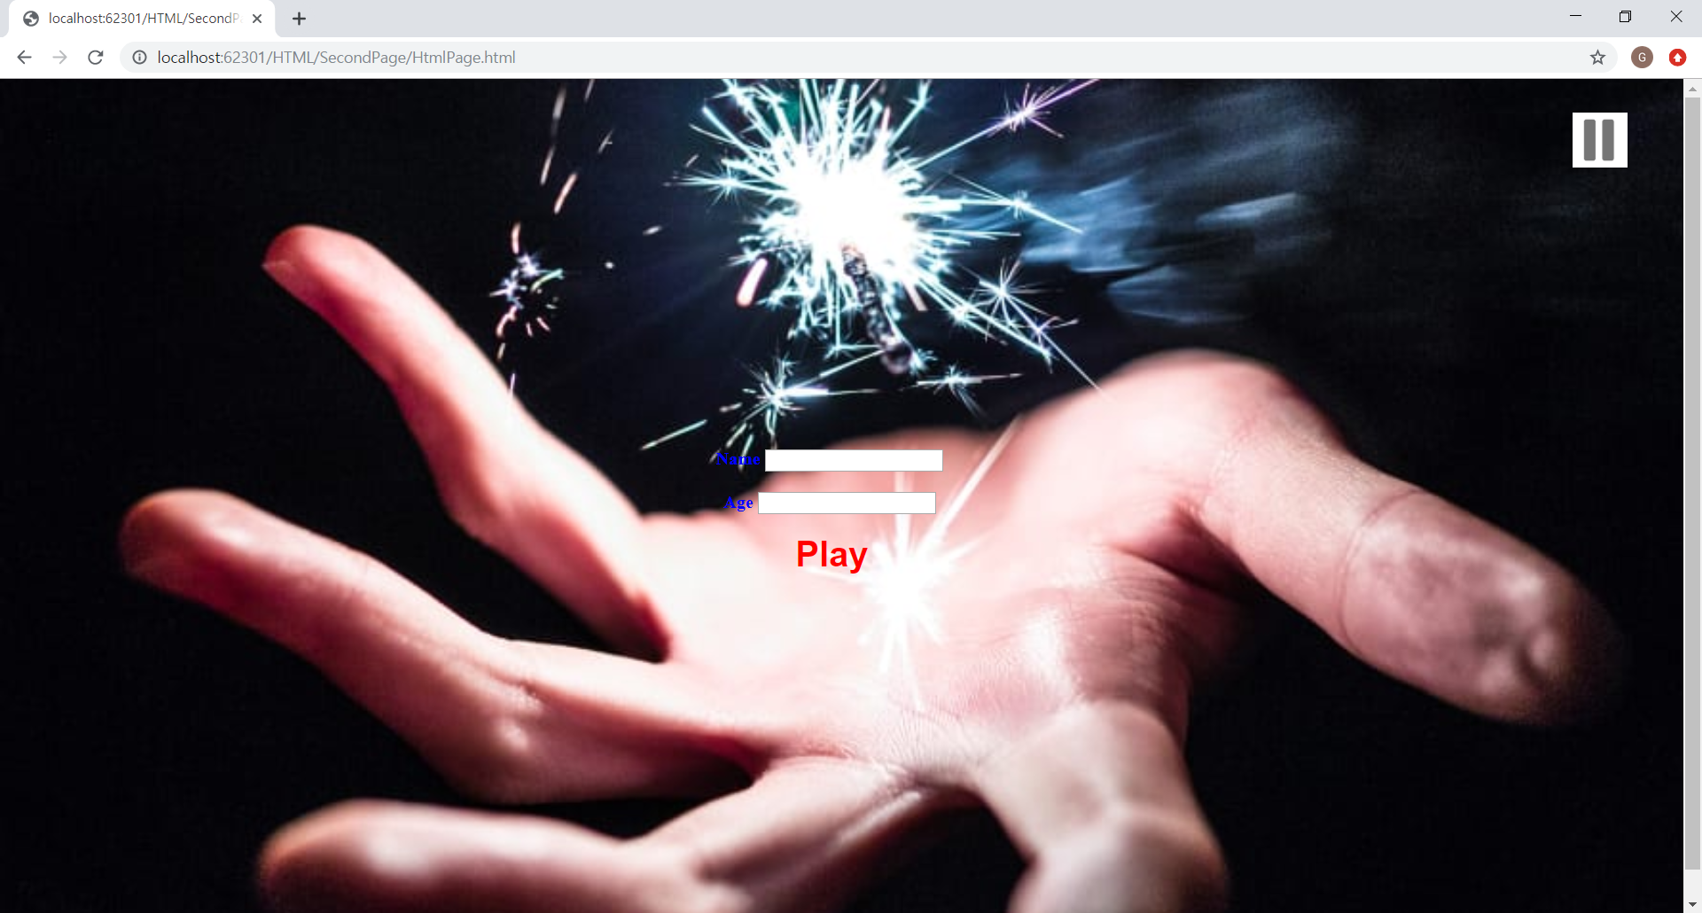

**Level1 Page (Add)**

**HTML**

<!DOCTYPE html>

<html>

<head>

<meta charset="utf-8" />

<title></title>

<link href="../../CSS/Level1/StyleSheet.css" rel="stylesheet" type="text/css" />

</head>

<body id="body" onmousemove="showCoords(event)">

<h1 id="h1">

Magic Math Game

</h1>

<div id="music"></div>

<div id="questionContainer">

<h5 id="question"></h5>

</div>

<section id="movingArea">

<div id="num1">

<p id="num1Value"></p>

</div>

<div id="num2">

<p id="num2Value"></p>

</div>

<div id="num3">

<p id="num3Value"></p>

</div>

<div id="num4">

<p id="num4Value"></p>

</div>

<div id="num5">

<p id="num5Value"></p>

</div>

<div id="num6">

<p id="num6Value"></p>

</div>

<div id="num7">

<p id="num7Value"></p>

</div>

<div id="num8">

<p id="num8Value"></p>

</div>

<div id="num9">

<p id="num9Value"></p>

</div>

</section>

<div id="infoBox">

<label>SCORE: </label> <label id="score"> 0 </label> <br />

<label>H I T S : </label> <label id="hits"> 0 </label> <br />

<label>M I S S : </label> <label id="miss"> 0 </label> <br />

<label>T I M E : </label> <label id="time"> </label> <br />

</div>

<div id="saveContainer">

<input type="button" id="saveBtn" value="save" />

</div>

<script src="../../JavaScript/Level1/JavaScript.js"></script>

</body>

</html>

**CSS**

* {

padding: 0;

margin: 0;

}

#body {

background-image: url("../../Image/giphy.gif");

background-size:cover;

background-repeat:no-repeat;

background-position:center center;

height:100vh;

text-align:center;

}

h1 {

font-size: 3rem;

display:inline-block;

}

#questionContainer {

position:absolute;

color:red;

font-size:3rem;

}

#music {

position: absolute;

background-image: url("../../Image/Pause.png");

width: 50px;

height: 50px;

background-size: cover;

background-repeat: no-repeat;

background-position: center;

z-index:30;

}

#saveContainer {

position:absolute;

z-index:30;

}

#saveBtn {

width:80px;

height:2rem;

}

#movingArea {

position: absolute;

}

#movingArea > div {

background-image: url("../../Image/card back.png");

background-size: cover;

background-repeat: no-repeat;

background-position: center center;

height: 100px;

width: 100px;

position: absolute;

}

#infoBox {

background-color: none;

color:red;

font-size:2rem;

display: inline-block;

position:absolute;

}

label {

font-size:1.5rem;

}

p {

font-size:4rem;

}

**JavaScript**

const infoBox = document.querySelector("#infoBox");

const body = document.querySelector("#body");

// ScoreBox position

infoBox.style.left = `${body.offsetWidth - (infoBox.offsetWidth + 80)}px`;

infoBox.style.top = `${body.offsetHeight - infoBox.offsetHeight}px`;

const movingArea = document.querySelector("#movingArea");

const h1Size = document.querySelector("#h1");

const question = document.querySelector("#question");

// moving area

movingArea.style.height = `${body.offsetHeight - infoBox.offsetHeight - h1Size.offsetHeight}px`;

movingArea.style.width = `${body.offsetWidth}px`;

// creating question

let qNum1 = Math.floor(Math.random() * 25) + 1;

let qNum2 = Math.floor(Math.random() * 9) + 1;

const createQuestion = (qNum1, qNum2) => {

question.innerHTML = `Q: ${qNum1} + ${qNum2}`;

}

// music

const music = document.querySelector("#music");

music.style.left = `${body.offsetWidth - 100}px`;

music.style.top = `${30}px`;

var audio = new Audio("../../Audio/Shallow .mp3");

audio.currentTime = JSON.parse(localStorage.getItem("Music"));

audio.play();

let flag = 0;

music.addEventListener("click", () => {

console.log("Btn Click");

// play music

if (flag) {

music.style.backgroundImage = "url(../../Image/Pause.png)";

audio.play();

flag = 0;

}

// pause music

else {

music.style.backgroundImage = "url(../../Image/play.jpg)";

audio.pause();

flag = 1;

}

});

const numberDivs = [

document.querySelector("#num1"),

document.querySelector("#num2"),

document.querySelector("#num3"),

document.querySelector("#num4"),

document.querySelector("#num5"),

document.querySelector("#num6"),

document.querySelector("#num7"),

document.querySelector("#num8"),

document.querySelector("#num9")

]

const numbersValues = [

document.querySelector("#num1Value"),

document.querySelector("#num2Value"),

document.querySelector("#num3Value"),

document.querySelector("#num4Value"),

document.querySelector("#num5Value"),

document.querySelector("#num6Value"),

document.querySelector("#num7Value"),

document.querySelector("#num8Value"),

document.querySelector("#num9Value")

]

// change position

const moveElement = () => {

for (var i = 0; i < numberDivs.length; i++) {

const newHeight = (Math.random() * (body.offsetHeight - 170));

const newWidth = (Math.random() * (body.offsetWidth - 100));

numberDivs[i].style.top = `${newHeight}px`;

numberDivs[i].style.left = `${newWidth}px`;

}

}

// create random questions

const createNumbers = (qNum1, qNum2) => {

const wrongNumbers = [];

while (true) {

const val1 = Math.floor(Math.random() * 26);

const val2 = Math.floor(Math.random() * 10);

if ((val1 + val2) == (qNum1 + qNum2))

continue;

else {

for (var i = 0; i < wrongNumbers.length; i++) {

if ((val1 + val2) == wrongNumbers[i])

continue;

}

wrongNumbers.push(val1 + val2);

}

if (wrongNumbers.length == 8)

break;

}

numbersValues[0].innerHTML = `${qNum1 + qNum2}`;

numberDivs[0].appendChild(numbersValues[0]);

for (var i = 1; i <= wrongNumbers.length; i++) {

numbersValues[i].innerHTML = `${wrongNumbers[i - 1]}`;

numberDivs[i].appendChild(numbersValues[i]);

}

}

window.addEventListener("load", createQuestion(qNum1, qNum2));

window.addEventListener("load", createNumbers(qNum1, qNum2));

setInterval(moveElement, 2000);

const score = document.querySelector("#score");

const hits = document.querySelector("#hits");

const miss = document.querySelector("#miss");

// Correct Answer

const scoreValue = {

scoreNum: 0,

hitsNum: 0,

missNum: 0

}

const saveFile = JSON.parse(localStorage.getItem("saved"));

if (saveFile) {

scoreValue.scoreNum = `${JSON.parse(localStorage.getItem("totalScore"))}`;

scoreValue.hitsNum = `${JSON.parse(localStorage.getItem("lv1Hit"))}`;

scoreValue.missNum = `${JSON.parse(localStorage.getItem("lv1Miss"))}`;

}

score.innerHTML = `${scoreValue.scoreNum}`;

hits.innerHTML = `${scoreValue.hitsNum}`;

miss.innerHTML = `${scoreValue.missNum}`;

const correct = () => {

scoreValue.scoreNum += 10;

scoreValue.hitsNum++;

score.innerHTML = `${scoreValue.scoreNum}`;

hits.innerHTML = `${scoreValue.hitsNum}`;

let qNum1 = Math.floor(Math.random() * 26);

let qNum2 = Math.floor(Math.random() * 10);

createQuestion(qNum1, qNum2);

createNumbers(qNum1, qNum2);

}

// Wrong Answer

const wrong = () => {

if (scoreValue.scoreNum > 0)

scoreValue.scoreNum -= 10;

scoreValue.missNum++;

if (scoreValue.missNum == 6) {

alert(`Game Over`);

localStorage.setItem("totalScore", JSON.stringify(scoreValue.scoreNum));

localStorage.setItem("lv1Hit", JSON.stringify(scoreValue.hitsNum));

localStorage.setItem("lv1Miss", JSON.stringify(scoreValue.missNum));

localStorage.setItem("Music", audio.currentTime);

window.location.href = "../../HTML/Result Page/HtmlPage.html";

}

score.innerHTML = `${scoreValue.scoreNum}`;

miss.innerHTML = `${scoreValue.missNum}`;

let qNum1 = Math.floor(Math.random() * 26);

let qNum2 = Math.floor(Math.random() * 10);

createQuestion(qNum1, qNum2);

createNumbers(qNum1, qNum2);

}

numbersValues[0].addEventListener("click", correct);

for (var i = 1; i < numberDivs.length; i++)

numberDivs[i].addEventListener("click", wrong);

//set Time

const time = document.querySelector("#time");

let timeNum;

if (saveFile)

timeNum = `${JSON.parse(localStorage.getItem("time"))}`;

else

timeNum = 0;

const increaseTime = () => {

timeNum++;

time.innerHTML = `${timeNum}`;

// next game

if (timeNum == 90) {

alert(`Time Over`);

localStorage.setItem("totalScore", JSON.stringify(scoreValue.scoreNum));

localStorage.setItem("lv1Hit", JSON.stringify(scoreValue.hitsNum));

localStorage.setItem("lv1Miss", JSON.stringify(scoreValue.missNum));

localStorage.setItem("Music", audio.currentTime);

localStorage.setItem("time", 0);

localStorage.setItem("saved", 0);

window.location.href = "../../HTML/Level2/HtmlPage.html";

}

}

setInterval(increaseTime, 1000);

// mouse position

function showCoords(event) {

document.querySelector("#questionContainer").style.left = `${event.clientX}px`;

document.querySelector("#questionContainer").style.top = `${event.clientY}px`;

}

// Save

const saveContainer = document.querySelector("#saveContainer");

const saveBtn = document.querySelector("#saveBtn");

saveContainer.style.top = `${body.offsetHeight - saveContainer.offsetHeight}px`;

saveBtn.addEventListener("click", () => {

let level = 1;

let isSaved = 1;

console.log("saveBtn");

localStorage.setItem("totalScore", JSON.stringify(scoreValue.scoreNum));

localStorage.setItem("lv1Hit", JSON.stringify(scoreValue.hitsNum));

localStorage.setItem("lv1Miss", JSON.stringify(scoreValue.missNum));

localStorage.setItem("level", JSON.stringify(level));

localStorage.setItem("time", JSON.stringify(timeNum));

localStorage.setItem("saved", JSON.stringify(isSaved));

window.location.href = "../../HTML/FirstPage/HtmlPage.html";

});**Screen**

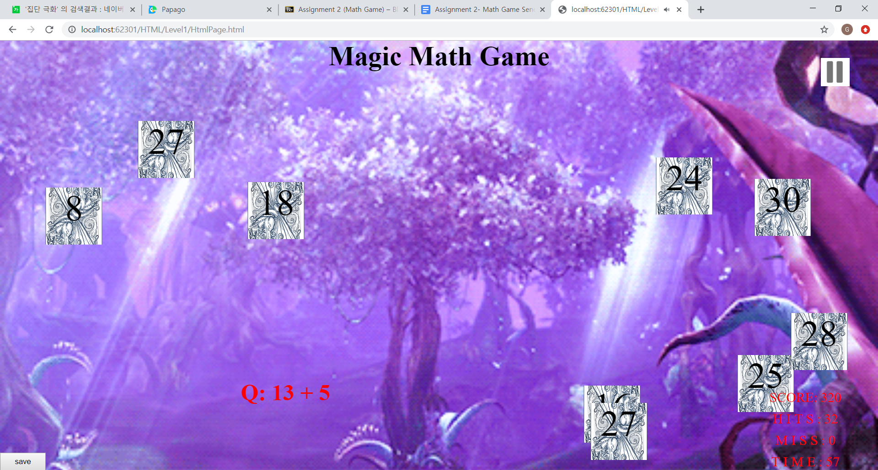

**Level2 Page (Sub)**

**HTML**

<!DOCTYPE html>

<html>

<head>

<meta charset="utf-8" />

<title></title>

<link href="../../CSS/Level2/StyleSheet.css" rel="stylesheet" type="text/css" />

</head>

<body id="body" onmousemove="showCoords(event)">

<h1 id="h1">

Magic Math Game

</h1>

<div id="music"></div>

<div id="questionContainer">

<h5 id="question"></h5>

</div>

<section id="movingArea">

<div id="num1">

<p id="num1Value"></p>

</div>

<div id="num2">

<p id="num2Value"></p>

</div>

<div id="num3">

<p id="num3Value"></p>

</div>

<div id="num4">

<p id="num4Value"></p>

</div>

<div id="num5">

<p id="num5Value"></p>

</div>

<div id="num6">

<p id="num6Value"></p>

</div>

<div id="num7">

<p id="num7Value"></p>

</div>

<div id="num8">

<p id="num8Value"></p>

</div>

<div id="num9">

<p id="num9Value"></p>

</div>

</section>

<div id="infoBox">

<label>SCORE: </label> <label id="score"> </label> <br />

<label>H I T S : </label> <label id="hits"> </label> <br />

<label>M I S S : </label> <label id="miss"> </label> <br />

<label>T I M E : </label> <label id="time"> </label> <br />

</div>

<div id="saveContainer">

<input type="button" id="saveBtn" value="save" />

</div>

<script src="../../JavaScript/Level2/JavaScript.js"></script>

</body>

</html>

**CSS**

* {

padding: 0;

margin: 0;

}

#body {

background-image: url("../../Image/Level2.gif");

background-size: cover;

background-repeat: no-repeat;

background-position: center center;

height: 100vh;

text-align: center;

}

h1 {

font-size: 3rem;

color:red;

}

#questionContainer {

position: absolute;

color: red;

font-size: 3rem;

}

#music {

position: absolute;

background-image:url("../../Image/Pause.png");

width: 50px;

height: 50px;

background-size: cover;

background-repeat: no-repeat;

background-position: center;

z-index:30;

}

#saveContainer {

position: absolute;

z-index: 40;

}

#saveBtn {

width: 80px;

height: 2rem;

}

#movingArea {

position: absolute;

}

#movingArea > div {

background-image: url("../../Image/card back.png");

background-size: cover;

background-repeat: no-repeat;

background-position: center center;

height: 100px;

width: 100px;

position: absolute;

}

#infoBox {

background-color: none;

color: red;

font-size: 2rem;

display: inline-block;

position: absolute;

}

label {

font-size: 1.5rem;

}

p {

font-size: 4rem;

}

**JavaScript**

const infoBox = document.querySelector("#infoBox");

const body = document.querySelector("#body");

// ScoreBox position

infoBox.style.left = `${body.offsetWidth - (infoBox.offsetWidth + 80)}px`;

infoBox.style.top = `${body.offsetHeight - infoBox.offsetHeight}px`;

const movingArea = document.querySelector("#movingArea");

const h1Size = document.querySelector("#h1");

// moving area

movingArea.style.height = `${body.offsetHeight - infoBox.offsetHeight - h1Size.offsetHeight}px`;

movingArea.style.width = `${body.offsetWidth}px`;

const question = document.querySelector("#question");

// creating question Number

let qNum1 = Math.floor(Math.random() * 26);

let qNum2 = Math.floor(Math.random() * 10);

const createQuestion = (qNum1, qNum2) => {

question.innerHTML = `Q: ${qNum1} - ${qNum2}`;

}

// music

const music = document.querySelector("#music");

music.style.left = `${body.offsetWidth - 100}px`;

music.style.top = `${30}px`;

var audio = new Audio("../../Audio/Shallow .mp3");

audio.currentTime = JSON.parse(localStorage.getItem("Music"));

audio.play();

let flag = 1;

music.addEventListener("click", () => {

// play music when it is paused

if (flag) {

music.style.backgroundImage = "url(../../Image/Pause.png)";

audio.play();

flag = 0;

}

// pause music

else {

audio.pause();

music.style.backgroundImage = "url(../../Image/play.jpg)";

flag = 1;

}

});

const numberDivs = [

document.querySelector("#num1"),

document.querySelector("#num2"),

document.querySelector("#num3"),

document.querySelector("#num4"),

document.querySelector("#num5"),

document.querySelector("#num6"),

document.querySelector("#num7"),

document.querySelector("#num8"),

document.querySelector("#num9")

]

const numbersValues = [

document.querySelector("#num1Value"),

document.querySelector("#num2Value"),

document.querySelector("#num3Value"),

document.querySelector("#num4Value"),

document.querySelector("#num5Value"),

document.querySelector("#num6Value"),

document.querySelector("#num7Value"),

document.querySelector("#num8Value"),

document.querySelector("#num9Value")

]

// change position

const moveElement = () => {

for (var i = 0; i < numberDivs.length; i++) {

const newHeight = (Math.random() * (body.offsetHeight - 170));

const newWidth = (Math.random() * (body.offsetWidth - 100));

numberDivs[i].style.top = `${newHeight}px`;

numberDivs[i].style.left = `${newWidth}px`;

}

}

// create random answers

const createNumbers = (qNum1, qNum2) => {

const wrongNumbers = [];

while (true) {

const val1 = Math.floor(Math.random() * 26);

const val2 = Math.floor(Math.random() * 10);

if ((val1 - val2) == (qNum1 - qNum2))

continue;

else {

for (var i = 0; i < wrongNumbers.length; i++) {

if ((val1 - val2) == wrongNumbers[i])

continue;

}

wrongNumbers.push(val1 - val2);

}

if (wrongNumbers.length == 8)

break;

}

numbersValues[0].innerHTML = `${qNum1 - qNum2}`;

numberDivs[0].appendChild(numbersValues[0]);

for (var i = 0; i < wrongNumbers.length; i++) {

numbersValues[i + 1].innerHTML = `${wrongNumbers[i]}`;

numberDivs[i + 1].appendChild(numbersValues[i + 1]);

}

}

window.addEventListener("load", createQuestion(qNum1, qNum2));

window.addEventListener("load", createNumbers(qNum1, qNum2));

setInterval(moveElement, 2000);

const score = document.querySelector("#score");

const hits = document.querySelector("#hits");

const miss = document.querySelector("#miss");

// Correct Answer

const data = JSON.parse(localStorage.getItem("totalScore"));

const scoreValue = {

scoreNum: data,

hitsNum: 0,

missNum: 0

}

const saveFile = JSON.parse(localStorage.getItem("saved"));

if (saveFile) {

scoreValue.scoreNum = `${JSON.parse(localStorage.getItem("totalScore"))}`;

scoreValue.hitsNum = `${JSON.parse(localStorage.getItem("lv2Hit"))}`;

scoreValue.missNum = `${JSON.parse(localStorage.getItem("lv2Miss"))}`;

}

score.innerHTML = `${scoreValue.scoreNum}`;

hits.innerHTML = `${scoreValue.hitsNum}`;

miss.innerHTML = `${scoreValue.missNum}`;

const correct = () => {

scoreValue.scoreNum += 10;

scoreValue.hitsNum++;

score.innerHTML = `${scoreValue.scoreNum}`;

hits.innerHTML = `${scoreValue.hitsNum}`;

let qNum1 = Math.floor(Math.random() * 26);

let qNum2 = Math.floor(Math.random() * 10);

createQuestion(qNum1, qNum2);

createNumbers(qNum1, qNum2);

}

// Wrong Answer

const wrong = () => {

if (scoreValue.scoreNum > 0)

scoreValue.scoreNum -= 10;

scoreValue.missNum++;

if (scoreValue.missNum == 6) {

alert(`Game Over`);

localStorage.setItem("totalScore", JSON.stringify(scoreValue.scoreNum));

localStorage.setItem("lv2Hit", JSON.stringify(scoreValue.hitsNum));

localStorage.setItem("lv3Miss", JSON.stringify(scoreValue.missNum));

localStorage.setItem("Music", audio.currentTime);

window.location.href = "../../HTML/Result Page/HtmlPage.html";

}

score.innerHTML = `${scoreValue.scoreNum}`;

miss.innerHTML = `${scoreValue.missNum}`;

let qNum1 = Math.floor(Math.random() * 26);

let qNum2 = Math.floor(Math.random() * 10);

createQuestion(qNum1, qNum2);

createNumbers(qNum1, qNum2);

}

numbersValues[0].addEventListener("click", correct);

for (var i = 1; i < numberDivs.length; i++)

numberDivs[i].addEventListener("click", wrong);

//set Time

const time = document.querySelector("#time");

let timeNum;

if (saveFile)

timeNum = `${JSON.parse(localStorage.getItem("time"))}`;

else

timeNum = 0;const increaseTime = () => {

timeNum++;

time.innerHTML = `${timeNum}`;

// next game

if (timeNum == 120) {

alert(`Time Over`);

localStorage.setItem("totalScore", JSON.stringify(scoreValue.scoreNum));

localStorage.setItem("lv2Hit", JSON.stringify(scoreValue.hitsNum));

localStorage.setItem("lv2Miss", JSON.stringify(scoreValue.missNum));

localStorage.setItem("Music", audio.currentTime);

localStorage.setItem("time", 0);

localStorage.setItem("saved", 0);

window.location.href = "../../HTML/Level3/HtmlPage.html";

}

}

setInterval(increaseTime, 1000);

// question position

function showCoords(event) {

document.querySelector("#questionContainer").style.left = `${event.clientX}px`;

document.querySelector("#questionContainer").style.top = `${event.clientY}px`;

}

// Save

const saveContainer = document.querySelector("#saveContainer");

const saveBtn = document.querySelector("#saveBtn");

saveContainer.style.top = `${body.offsetHeight - saveContainer.offsetHeight}px`;

saveBtn.addEventListener("click", () => {

let level = 2;

let isSaved = 1;

console.log("saveBtn");

localStorage.setItem("totalScore", JSON.stringify(scoreValue.scoreNum));

localStorage.setItem("lv2Hit", JSON.stringify(scoreValue.hitsNum));

localStorage.setItem("lv2Miss", JSON.stringify(scoreValue.missNum));

localStorage.setItem("level", JSON.stringify(level));

localStorage.setItem("time", JSON.stringify(timeNum));

localStorage.setItem("saved", JSON.stringify(isSaved));

window.location.href = "../../HTML/FirstPage/HtmlPage.html";

});

**Screen**

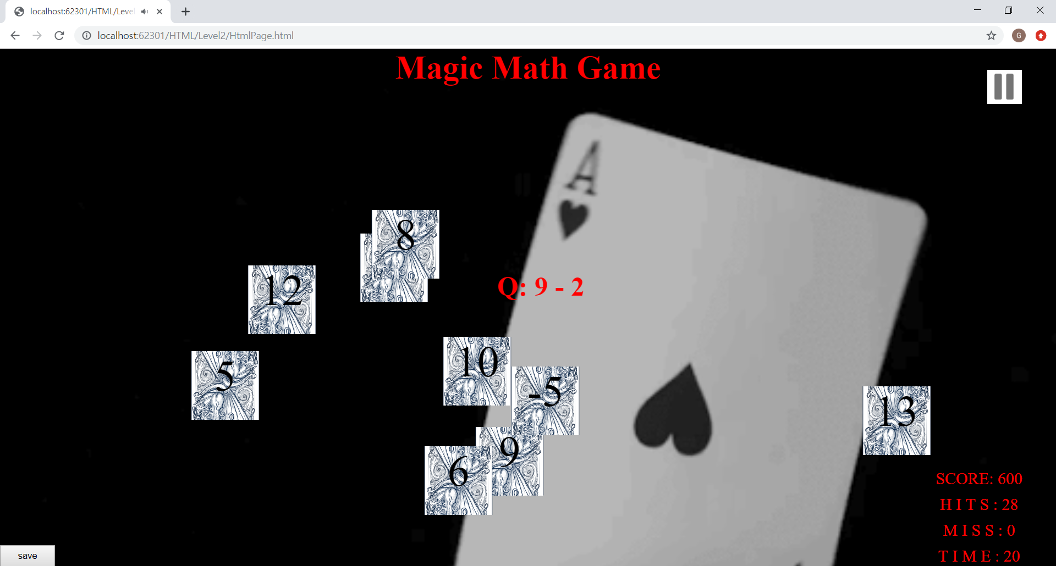

**Level3 Page (Div)**

**HTML**

<!DOCTYPE html>

<html>

<head>

<meta charset="utf-8" />

<title></title>

<link href="../../CSS/Level3/StyleSheet.css" rel="stylesheet" type="text/css" />

</head>

<body id="body" onmousemove="showCoords(event)">

<h1 id="h1">

Magic Math Game

</h1>

<div id="music"></div>

<div id="questionContainer">

<h5 id="question"></h5>

</div>

<section id="movingArea">

<div id="num1">

<p id="num1Value"></p>

</div>

<div id="num2">

<p id="num2Value"></p>

</div>

<div id="num3">

<p id="num3Value"></p>

</div>

<div id="num4">

<p id="num4Value"></p>

</div>

<div id="num5">

<p id="num5Value"></p>

</div>

<div id="num6">

<p id="num6Value"></p>

</div>

<div id="num7">

<p id="num7Value"></p>

</div>

<div id="num8">

<p id="num8Value"></p>

</div>

<div id="num9">

<p id="num9Value"></p>

</div>

</section>

<div id="infoBox">

<label>SCORE: </label> <label id="score"> </label> <br />

<label>H I T S : </label> <label id="hits"> </label> <br />

<label>M I S S : </label> <label id="miss"> </label> <br />

<label>T I M E : </label> <label id="time"> </label> <br />

</div>

<div id="saveContainer">

<input type="button" id="saveBtn" value="save" />

</div>

<script src="../../JavaScript/Level3/JavaScript.js"></script>

</body>

</html>

**CSS**

* {

padding: 0;

margin: 0;

}

#body {

background-image: url("../../Image/Level3.gif");

background-size: cover;

background-repeat: no-repeat;

background-position: center center;

height: 100vh;

text-align: center;

}

h1 {

font-size: 3rem;

}

#questionContainer {

position: absolute;

color: red;

font-size: 3rem;

}

#music {

position: absolute;

background-image: url("../../Image/Pause.png");

width: 50px;

height: 50px;

background-size: cover;

background-repeat: no-repeat;

background-position: center;

z-index:30;

}

#saveContainer {

position: absolute;

z-index: 40;

}

#saveBtn {

width: 80px;

height: 2rem;

}

#movingArea {

position: absolute;

}

#movingArea > div {

background-image: url("../../Image/card back.png");

background-size: cover;

background-repeat: no-repeat;

background-position: center center;

height: 100px;

width: 100px;

position: absolute;

}

#infoBox {

background-color: none;

color: red;

font-size: 2rem;

display: inline-block;

position: absolute;

}

label {

font-size: 1.5rem;

}

p {

font-size: 4rem;

}

**JavaScript**

const infoBox = document.querySelector("#infoBox");

const body = document.querySelector("#body");

// ScoreBox position

infoBox.style.left = `${body.offsetWidth - (infoBox.offsetWidth + 80)}px`;

infoBox.style.top = `${body.offsetHeight - infoBox.offsetHeight}px`;

const movingArea = document.querySelector("#movingArea");

const h1Size = document.querySelector("#h1");

const question = document.querySelector("#question");

// moving area

movingArea.style.height = `${body.offsetHeight - infoBox.offsetHeight - h1Size.offsetHeight}px`;

movingArea.style.width = `${body.offsetWidth}px`;

// creating question Number

let qNum1;

let qNum2;

const createQuestion = () => {

do {

qNum1 = Math.floor(Math.random() * 25 + 1);

qNum2 = Math.floor(Math.random() * 9 + 2);

} while ((qNum1 % qNum2))

question.innerHTML = `Q: ${qNum1} / ${qNum2}`;

}

// music

const music = document.querySelector("#music");

music.style.left = `${body.offsetWidth - 100}px`;

music.style.top = `${30}px`;

var audio = new Audio("../../Audio/Shallow .mp3");

audio.currentTime = JSON.parse(localStorage.getItem("Music"));

audio.play();

let flag = 1;

music.addEventListener("click", () => {

// play music when it is paused

if (flag) {

music.style.backgroundImage = "url(../../Image/Pause.png)";

audio.play();

flag = 0;

}

// pause music

else {

audio.pause();

music.style.backgroundImage = "url(../../Image/play.jpg)";

flag = 1;

}

});

const numberDivs = [

document.querySelector("#num1"),

document.querySelector("#num2"),

document.querySelector("#num3"),

document.querySelector("#num4"),

document.querySelector("#num5"),

document.querySelector("#num6"),

document.querySelector("#num7"),

document.querySelector("#num8"),

document.querySelector("#num9")

]

const numbersValues = [

document.querySelector("#num1Value"),

document.querySelector("#num2Value"),

document.querySelector("#num3Value"),

document.querySelector("#num4Value"),

document.querySelector("#num5Value"),

document.querySelector("#num6Value"),

document.querySelector("#num7Value"),

document.querySelector("#num8Value"),

document.querySelector("#num9Value")

]

// change position

const moveElement = () => {

for (var i = 0; i < numberDivs.length; i++) {

const newHeight = (Math.random() * (body.offsetHeight - 170));

const newWidth = (Math.random() * (body.offsetWidth - 100));

numberDivs[i].style.top = `${newHeight}px`;

numberDivs[i].style.left = `${newWidth}px`;

}

}

// create random answers

const createNumbers = () => {

const wrongNumbers = [];

let val1;

let val2;

while (true) {

val1 = Math.floor(Math.random() * 25 + 1);

val2 = Math.floor(Math.random() * 9 + 2);

if (val1 < val2 || (val1 % val2 != 0) || (qNum1 / qNum2) == (val1 / val2))

continue;

else {

for (let i = 0; i < wrongNumbers.length; i++) {

if ((parseInt(val1 / val2)) == wrongNumbers[i])

continue;

}

wrongNumbers.push(Math.floor(val1 / val2));

}

if (wrongNumbers.length == 8)

break;

}

numbersValues[0].innerHTML = `${Math.floor(qNum1 / qNum2)}`;

numberDivs[0].appendChild(numbersValues[0]);

for (var i = 0; i < wrongNumbers.length; i++) {

numbersValues[i + 1].innerHTML = `${wrongNumbers[i]}`;

numberDivs[i + 1].appendChild(numbersValues[i + 1]);

}

}

window.addEventListener("load", createQuestion());

window.addEventListener("load", createNumbers());

setInterval(moveElement, 2000);

const score = document.querySelector("#score");

const hits = document.querySelector("#hits");

const miss = document.querySelector("#miss");

// Correct Answer

const data = JSON.parse(localStorage.getItem("totalScore"));

const scoreValue = {

scoreNum: data,

hitsNum: 0,

missNum: 0

}

const saveFile = JSON.parse(localStorage.getItem("saved"));

if (saveFile) {

scoreValue.scoreNum = `${JSON.parse(localStorage.getItem("totalScore"))}`;

scoreValue.hitsNum = `${JSON.parse(localStorage.getItem("lv3Hit"))}`;

scoreValue.missNum = `${JSON.parse(localStorage.getItem("lv3Miss"))}`;

}

score.innerHTML = `${scoreValue.scoreNum}`;

hits.innerHTML = `${scoreValue.hitsNum}`;

miss.innerHTML = `${scoreValue.missNum}`;

const correct = () => {

scoreValue.scoreNum += 10;

scoreValue.hitsNum++;

score.innerHTML = `${scoreValue.scoreNum}`;

hits.innerHTML = `${scoreValue.hitsNum}`;

let qNum1 = Math.floor(Math.random() * 25 + 1);

let qNum2 = Math.floor(Math.random() * 9 + 2);

createQuestion(qNum1, qNum2);

createNumbers(qNum1, qNum2);

}

// Wrong Answer

const wrong = () => {

if (scoreValue.scoreNum > 0)

scoreValue.scoreNum -= 10;

scoreValue.missNum++;

if (scoreValue.missNum == 6) {

alert(`Game Over`);

localStorage.setItem("totalScore", JSON.stringify(scoreValue));

localStorage.setItem("lv3Hit", JSON.stringify(scoreValue.hitsNum));

localStorage.setItem("lv3Miss", JSON.stringify(scoreValue.missNum));

localStorage.setItem("Music", audio.currentTime);

window.location.href = "../../HTML/Result Page/HtmlPage.html";

}

score.innerHTML = `${scoreValue.scoreNum}`;

miss.innerHTML = `${scoreValue.missNum}`;

createQuestion(qNum1, qNum2);

createNumbers(qNum1, qNum2);

}

numbersValues[0].addEventListener("click", correct);

for (var i = 1; i < numberDivs.length; i++)

numberDivs[i].addEventListener("click", wrong);

//set Time

const time = document.querySelector("#time");

let timeNum;

if (saveFile)

timeNum = `${JSON.parse(localStorage.getItem("time"))}`;

else

timeNum = 0;const increaseTime = () => {

timeNum++;

time.innerHTML = `${timeNum}`;

// next game

if (timeNum == 150) {

alert(`Time Over`);

localStorage.setItem("totalScore", JSON.stringify(scoreValue));

localStorage.setItem("lv3Hit", JSON.stringify(scoreValue.hitsNum));

localStorage.setItem("lv3Miss", JSON.stringify(scoreValue.missNum));

localStorage.setItem("Music", audio.currentTime);

window.location.href = "../../HTML/Result Page/HtmlPage.html";

}

}

setInterval(increaseTime, 1000);

// question position

function showCoords(event) {

document.querySelector("#questionContainer").style.left = `${event.clientX}px`;

document.querySelector("#questionContainer").style.top = `${event.clientY}px`;

}

// Save

const saveContainer = document.querySelector("#saveContainer");

const saveBtn = document.querySelector("#saveBtn");

saveContainer.style.top = `${body.offsetHeight - saveContainer.offsetHeight}px`;

saveBtn.addEventListener("click", () => {

let level = 3;

let isSaved = 1;

console.log("saveBtn");

localStorage.setItem("totalScore", JSON.stringify(scoreValue.scoreNum));

localStorage.setItem("lv3Hit", JSON.stringify(scoreValue.hitsNum));

localStorage.setItem("lv3Miss", JSON.stringify(scoreValue.missNum));

localStorage.setItem("level", JSON.stringify(level));

localStorage.setItem("time", JSON.stringify(timeNum));

localStorage.setItem("saved", JSON.stringify(isSaved));

window.location.href = "../../HTML/FirstPage/HtmlPage.html";

});**Screen**

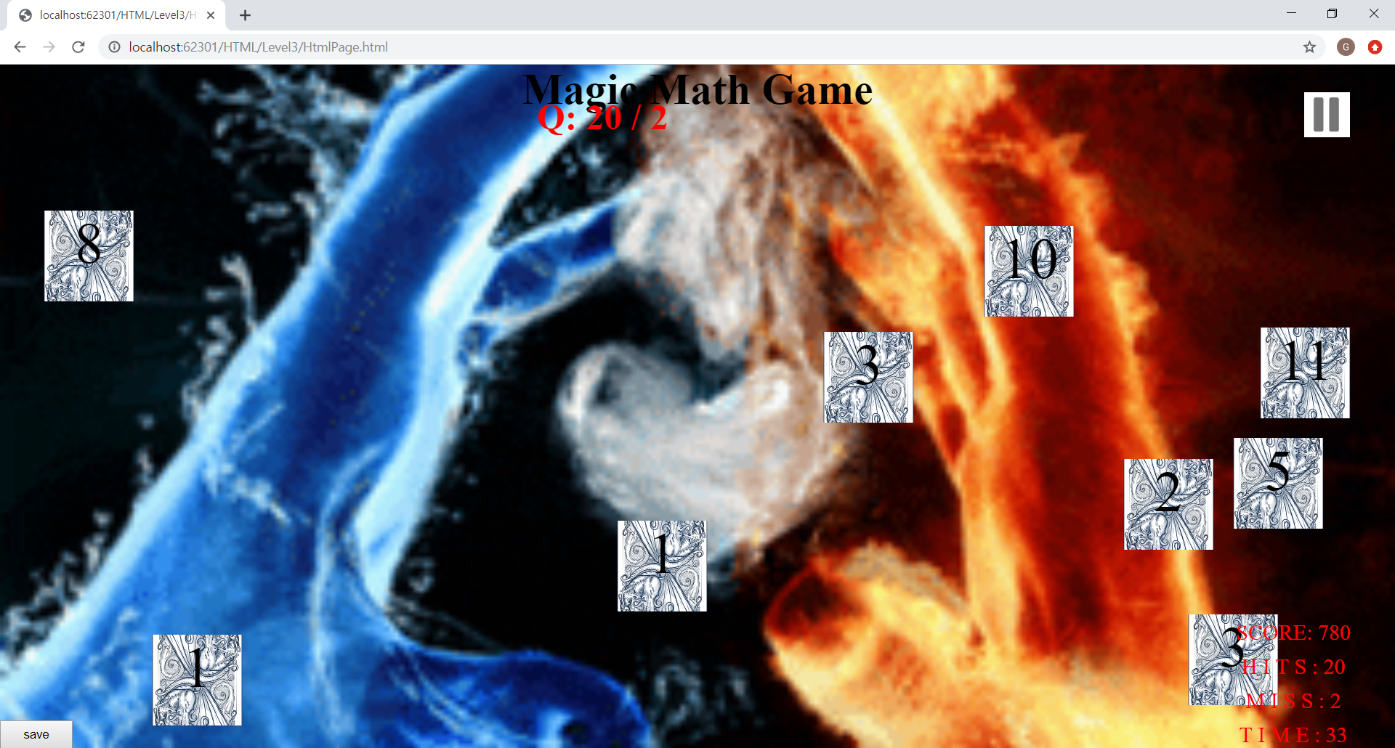

**Result Page (Div)**

**HTML**

<!DOCTYPE html>

<html>

<head>

<meta charset="utf-8" />

<title></title>

<link href="../../CSS/Result Page/StyleSheet.css" type="text/css" rel="stylesheet" />

</head>

<body id="body">

<div id="music"></div>

<div id="container">

<form>

<label id="userName"> Name :</label> <br />

<label id="userAge"> Age : </label> <br />

<label id="totalScore"> Total : </label>

</form>

<div id="gridDiv">

<div>

<h1>

Level1

</h1>

<label id="lv1HIT">HIT : </label> <br />

<label id="lv1MISS">MISS : </label>

</div>

<div>

<h1>

Level2

</h1>

<label id="lv2HIT">HIT : </label> <br />

<label id="lv2MISS">MISS : </label>

</div>

<div>

<h1>

Level3

</h1>

<label id="lv3HIT">HIT : </label> <br />

<label id="lv3MISS">MISS : </label>

</div>

</div>

</div>

<script src="../../JavaScript/Result Page/JavaScript.js"></script>

</body>

</html>

**CSS**

* {

margin:0;

padding:0;

}

body {

height:100vh;

width:100vh;

background-image:url("../../Image/Result.jpg");

background-position: center center;

background-repeat: no-repeat;

background-size: cover;

text-align:center;

}

#container {

position:absolute;

margin:10rem 0 0 25rem;

height: 500px;

width: 800px;

border: 2px solid black;

border-radius:80px 80px;

}

#music {

position: absolute;

background-image: url("../../Image/Pause.png");

width: 50px;

height: 50px;

background-size: cover;

background-repeat: no-repeat;

background-position: center;

margin-left:40rem;

}

#gridDiv {

display:grid;

grid-template-columns: 1fr 1fr 1fr;

}

#grid > div {

background-color:red;

}

label {

font-size:2rem;

}

h1 {

font-size:3rem;

color:red;

}

**JavaScript**

const userName = document.querySelector("#userName");

const userAge = document.querySelector("#userAge");

const totalScore = document.querySelector("#totalScore");

const body = document.querySelector("#body");

userName.innerHTML += JSON.parse(localStorage.getItem("userInfo")).userName;

userAge.innerHTML += JSON.parse(localStorage.getItem("userInfo")).userAge;;

totalScore.innerHTML += JSON.parse(localStorage.getItem("totalScore")).scoreNum;

const lv1HIT = document.querySelector("#lv1HIT");

const lv1MISS = document.querySelector("#lv1MISS");

const lv2HIT = document.querySelector("#lv2HIT");

const lv2MISS = document.querySelector("#lv2MISS");

const lv3HIT = document.querySelector("#lv3HIT");

const lv3MISS = document.querySelector("#lv3MISS");

lv1HIT.innerHTML += JSON.parse(localStorage.getItem("lv1Hit"));

lv1MISS.innerHTML += JSON.parse(localStorage.getItem("lv1Miss"));

lv2HIT.innerHTML += JSON.parse(localStorage.getItem("lv2Hit"));

lv2MISS.innerHTML += JSON.parse(localStorage.getItem("lv2Miss"));

lv3HIT.innerHTML += JSON.parse(localStorage.getItem("lv3Hit"));

lv3MISS.innerHTML += JSON.parse(localStorage.getItem("lv3Miss"));

// music

const music = document.querySelector("#music");

music.style.left = `${body.offsetWidth - 100}px`;

music.style.top = `${30}px`;

var audio = new Audio("../../Audio/Shallow .mp3");

audio.currentTime = JSON.parse(localStorage.getItem("Music"));

audio.play();

let flag = 1;

music.addEventListener("click", () => {

// play music when it is paused

if (flag) {

music.style.backgroundImage = "url(../../Image/Pause.png)";

audio.play();

flag = 0;

}

// pause music

else {

audio.pause();

music.style.backgroundImage = "url(../../Image/play.jpg)";

flag = 1;

}

});

**Screen**

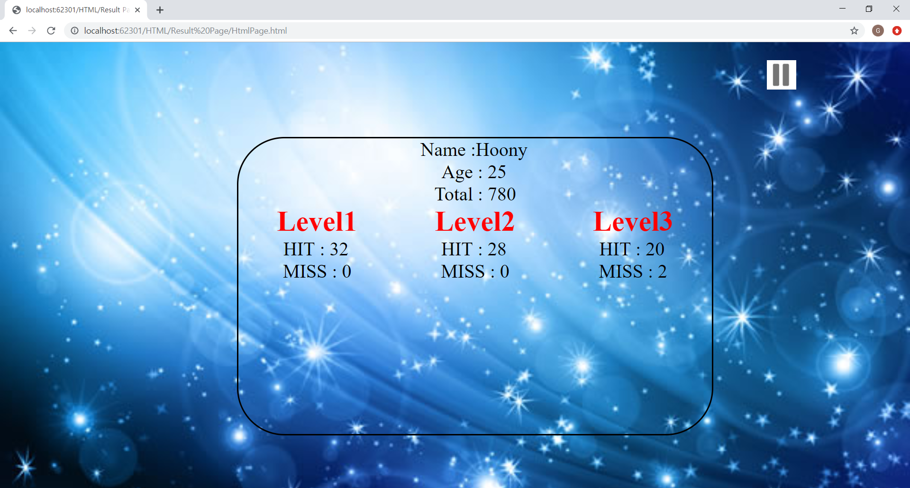

**Rules**

**HTML**

<!DOCTYPE html>

<html>

<head>

<meta charset="utf-8" />

<title></title>

<link href="../../CSS/Rules/StyleSheet.css" rel="stylesheet" type="text/css" />

</head>

<body>

<div id="container">

<h1> RULES </h1>

<ol>

<li> Every question that the game generates is displayed underneath the cursor and moves when the player moves the cursor within the game area.</li>

<li> For every generated question, the game must generate 9 possible answers, one correct answer and 8 incorrect answers. The 9 possible answers must all be generated on a separate fruit, similarly as shown in Figure 1.3. The generated answers (Ffurits) must be moving around throughout the game</li>

<li> The player aim for every question is to click on the fruit that he/she thinks is the corrct answer to the generated question.</li>

</ol>

</div>

<script src="../../JavaScript/Rules/JavaScript.js"></script>

</body>

</html>

**CSS**

* {

margin: 0;

padding: 0;

}

body {

height: 100vh;

width: 100vh;

background-image: url("../../Image/Result.jpg");

background-position: center center;

background-repeat: no-repeat;

background-size: cover;

text-align: center;

}

#container {

position: absolute;

margin: 10rem 0 0 25rem;

height: 500px;

width: 800px;

border: 2px solid black;

border-radius: 80px 80px;

}

ol {

padding : 3rem;

}

**Screen** 